A495-Can-NW-Haida-Humpback Whale Carving-20th century

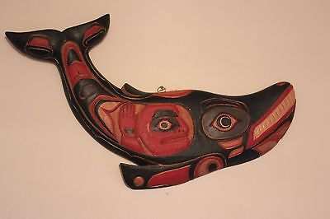

Formal Label: Canada Haida Humpback Whale Carving

Accession Number:A495

LC Classification: E 99.H2

Date or Time Horizon: 20th century

Geographical Area: British Columbia.

Cultural Affiliation: Haida

Medium: Cedar

Dimensions: L 39 cm; W 25 cmWeight:

Provenance: Haida

**Condition:** Museum quality.

**Discussion:** Whales are believed to offer themselves up as food to help the people survive, and therefore hold a special position of honor and respect. Men who were successful whalers were among the highest-esteemed members of traditional Northwest Coast societies. This visual rendition of a humpback whale has a human-fish in his belly as his captive as in the Jonah story.

**References:**

Wright, Robin K. 2001. *Northern Haida master carvers*. Seattle, WA: University of Washington Press.